Project Activity 2 – Start Coding

What were the requirements your team assigned to you?

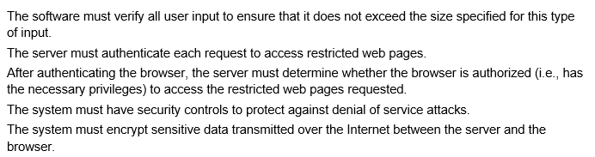

Please also do not forget to describe your team's application and its deliverables. What are the specific objectives of this application?

Our team had to strategize a website protection plan and implement it accordingly. Our DevOps implemented the website backup, the tech lead in the process of implementing the website vulnerability analysis, and the tester fixed the vulnerabilities and bugs (if any). The project manager captures all this and maintains the appropriate documentation.

Record your team member roles and their goals

## Strategy/Project Plan

Provide a brief description of your team’s strategy for completing this project.

Our plan is to complete the project by the end of the year, going step by step, following all requirements. Everyone is assigned a role and responsibilities, and each member does an excellent job of executing their roles and ideas. Backup of the site has been successfully done, next we plan to implement the project by finding vulnerabilities of the site and fixing them in passing.

## Using GitHub for Collaboration

What is the link to your GitHub repository?

<https://github.com/AbylaiShazhabayev/Security-of-Website>

Describe how GitHub was used to:

1. Describe/Create the master branch

<https://github.com/AbylaiShazhabayev/Security-of-Website/tree/main>

The master branch stores the base of our project, the database and the website with some content.

1. Describe/Create your branch

<https://github.com/AbylaiShazhabayev/Security-of-Website/tree/Documentation>

In the documentation branch, I keep all the necessary documentation for the project, since I am the project manager.

## Final Deliverables

### Presentation in class

Create a presentation about the project you selected. Your presentation should include:

* Information about your application, covering what features your team included
* The reasons that your team decided on these specific features in your application
* Application code of assigned parts, including comments and documentation. Your comments and documentation should be sufficient for any other team to be able to continue the project if required. Another team should be able to understand the application, your features and how to continue with the project
* Demonstration of your part of the application
* List of future enhancements (backlog) if neccessary
* Reflection points – what issues have you faced while working on this activity, how did you find solutions, what have you learned, etc.